**ADD SHADY CHARACTERS TO YOUR YARD**

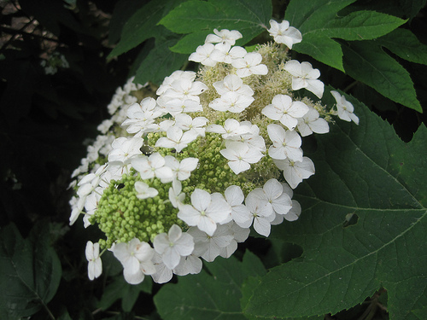

**Oakleaf Hydrangea *(Hydrangea quercifolia)*** is a large deciduous native shrub that works well as an understory planting under larger trees like live oaks. They make an attractive backdrop for other plants. The leaves are largest on plants grown in the shade, reaching up to 8 to 12 inches long and almost as wide. They turn red, bronze or purple in the fall and may stay on the plant well into winter.

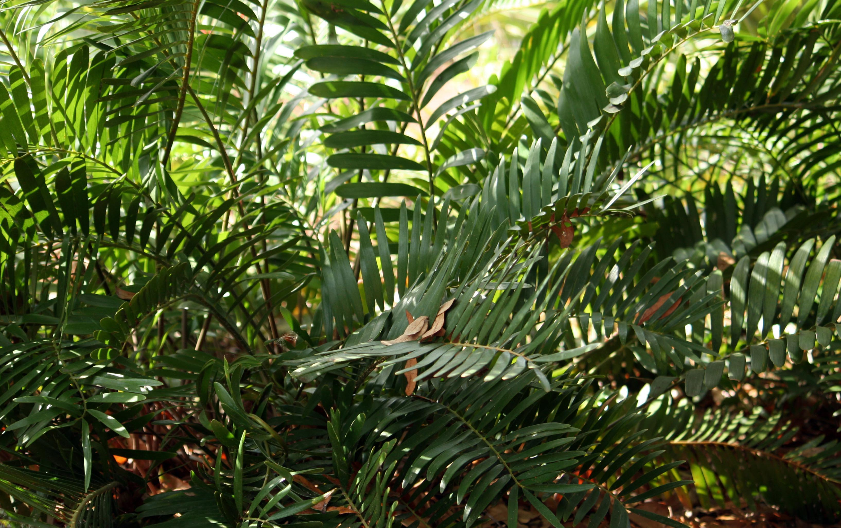

**Coontie *(Zamia pumila)*** looks like a small fern, and is typically three feet tall. This ancient plant has stiff, glossy, featherlike leaves attached to a thick, short, underground stem. Because of its cold hardiness, high drought tolerance and moderate salt tolerance, the coontie is an excellent choice for the coastal landscape. Coonties can be planted in sun or shade, and can be used as a specimen plant or in foundation and massed plantings throughout the state.

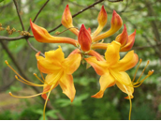

**Azalea *(Rhododendron sp.)*** This much-branched shrub is especially showy in flower. It’s a deciduous shrub, with terminal clusters of tubular, vase-shaped, slightly fragrant flowers, available in pink and orange/yellow.

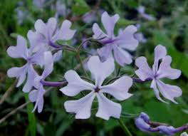

**Woodland Phlox *(Phlox divaricata)*** Native wild blue phlox is often found along streams and in open woods, but it is equally at home at the front of a flower border.Showy clusters of flowers in spring do well under deciduous trees and spread each season though are easy to dig up and propagate. The shallow root system benefits from mulching.

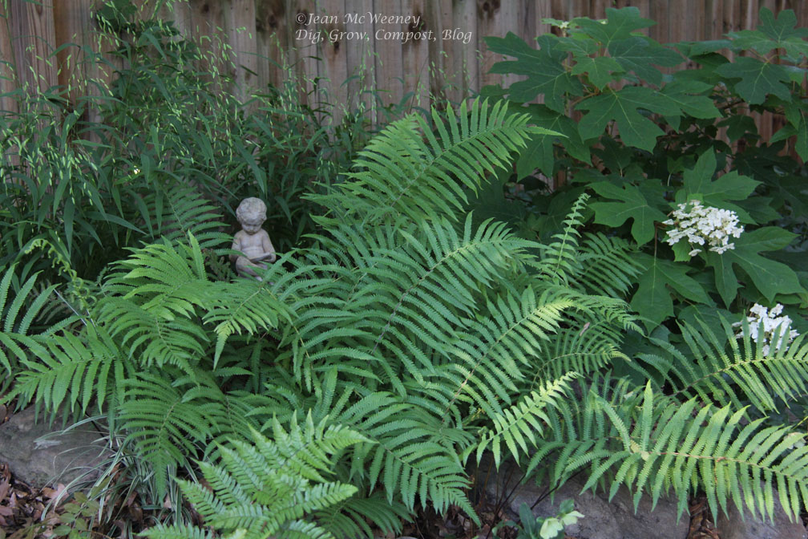

**Southern Wood Fern *(Thelypteris kunthii)*** This evergreen fern grows naturally in swamps and along stream banks though is adaptable to home landscapes. It grows 3 to 4 feet tall in light to full shade. It provides good groundcover foliage for shade in the hot Southeast and provides essential cover for wildlife such as frogs and lizards.

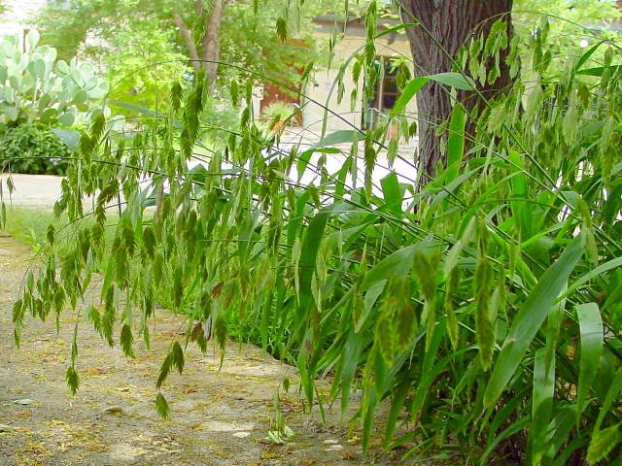**River Oats *(Chasmanthium latifolium)*** Very popular as a low-maintenance shade grass, River Oats are notable for their large, graceful seed heads. Sending up blue-green basal leaves in earliest spring, it can be 2 feet tall and a vivid green by May, with translucent green seed heads swaying in the breeze. It passes through most of winter a soft brown. It likes it shady and wet.

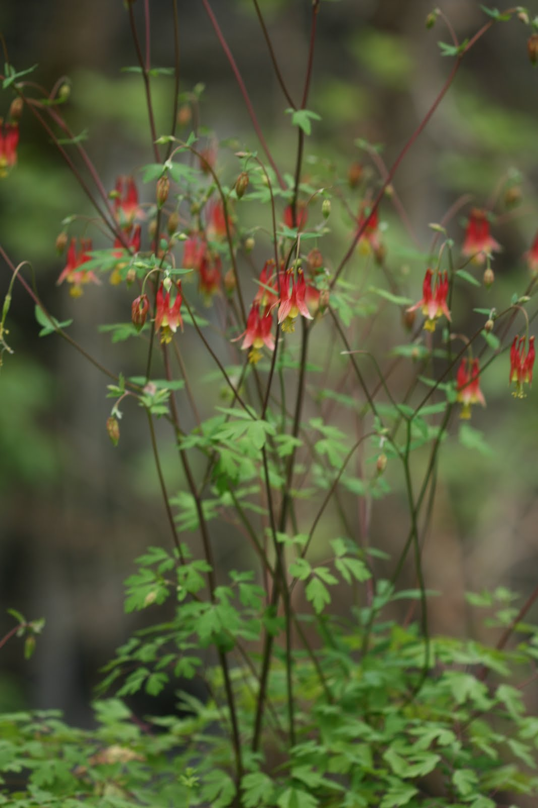

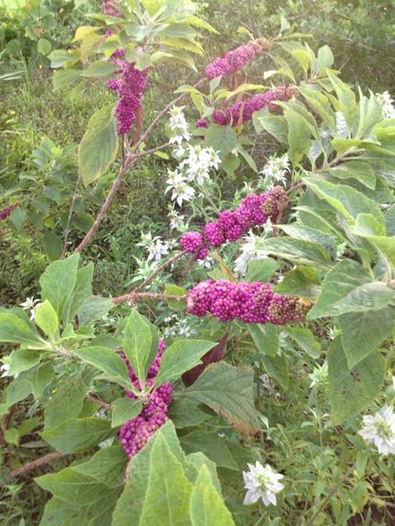**Columbine *(Aquilegia canadensis)*** This beautiful woodland wildflower has showy, drooping, bell-like flowers with distinctly backward-pointing tubes. These tubes, or spurs, contain nectar that attracts long-tongued insects and hummingbirds. Once started, Columbine propagates for years and, although perennial, increases rapidly by self seeding.

**Beautyberry (*Callicarpa americana)*** In the fall, the bright purple berries of the Beautyberry stand out in any garden. It is a deciduous shrub, may grow to about six feet tall and is a beautiful addition to woodland gardens and natural areas. Berries feed birds all winter. Combine Beautyberry with evergreen shrubs.

Also: Anise, Redbud, Chickasaw Plum, Pawpaw, Blueberry, Sparkleberry, Wild False Indigo, Saw Palmetto, Blue-stem Palmetto, Spicebush, Elderberry, Wild Coffee, Climbing Aster, Coral bean, Wild Petunia.